Power BI Version Control

> Created a Project called PBIDemo, and Repository called PBIDemo

> Created Build Pipeline as below

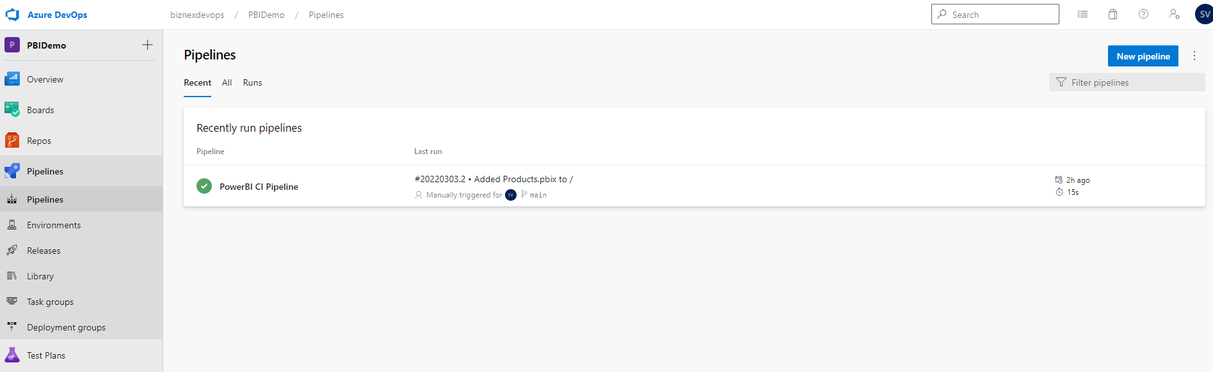

YAML file for Build Pipeline (CI)
# Starter pipeline
# Start with a minimal pipeline that you can customize to build and deploy your code.
# Add steps that build, run tests, deploy, and more:
# https://aka.ms/yaml

trigger:
- master

pool:
vmImage: 'ubuntu-latest'

steps:
- task: CopyFiles@2
inputs:
SourceFolder: '$(Build.SourcesDirectory)'
Contents: '**.pbix'
TargetFolder: '$(build.artifactstagingdirectory)'
OverWrite: true
- task: PublishBuildArtifacts@1
inputs:
PathtoPublish: '$(Build.ArtifactStagingDirectory)'
ArtifactName: 'drop'
publishLocation: 'Container'

- Release Pipeline

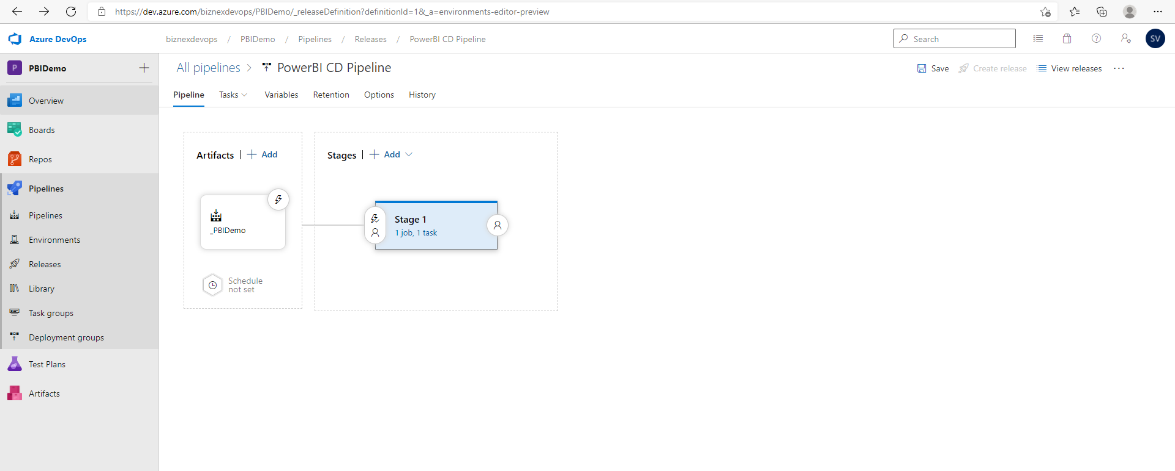

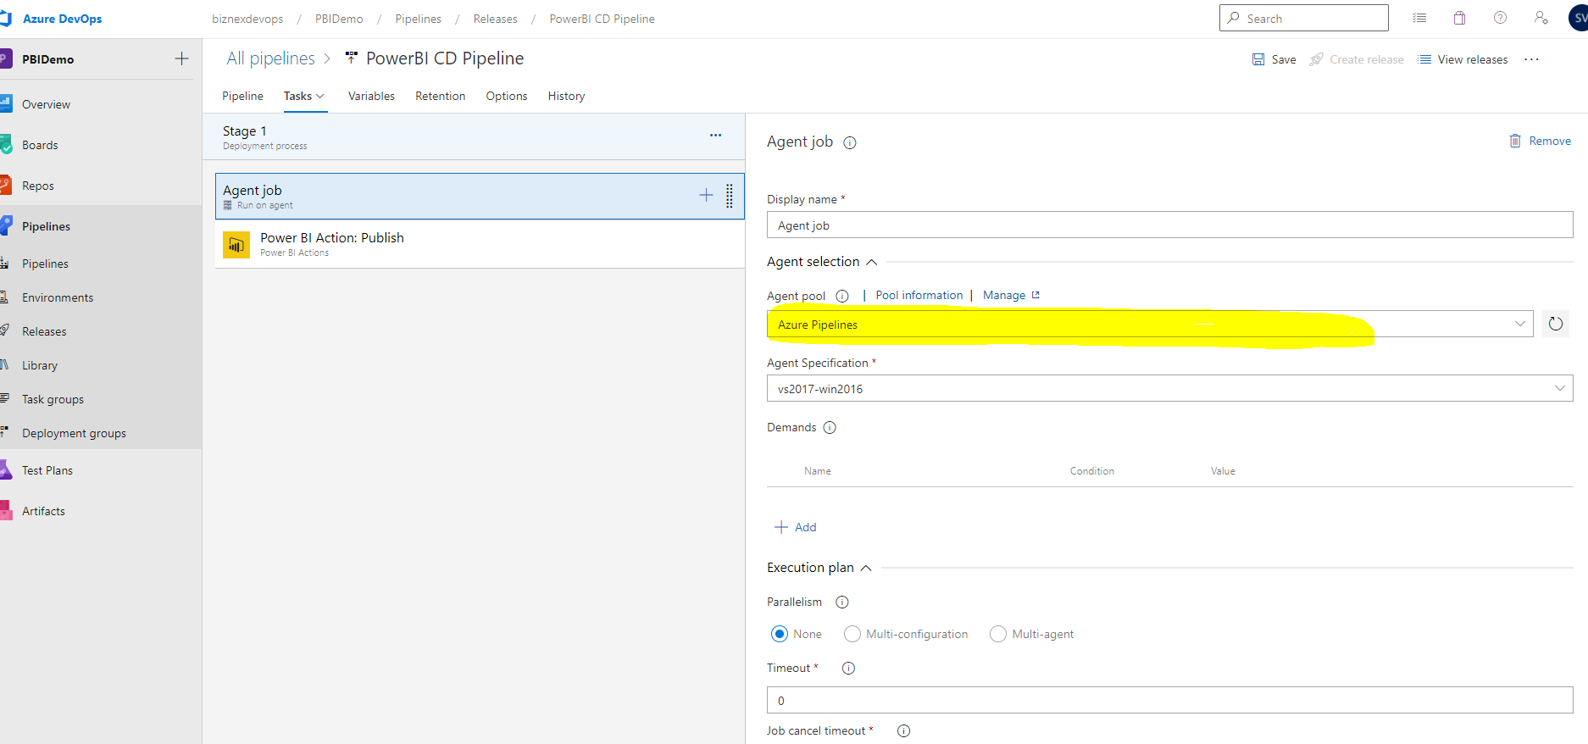

- Configuring Power Bi Service Connection for Power BI Action Task

